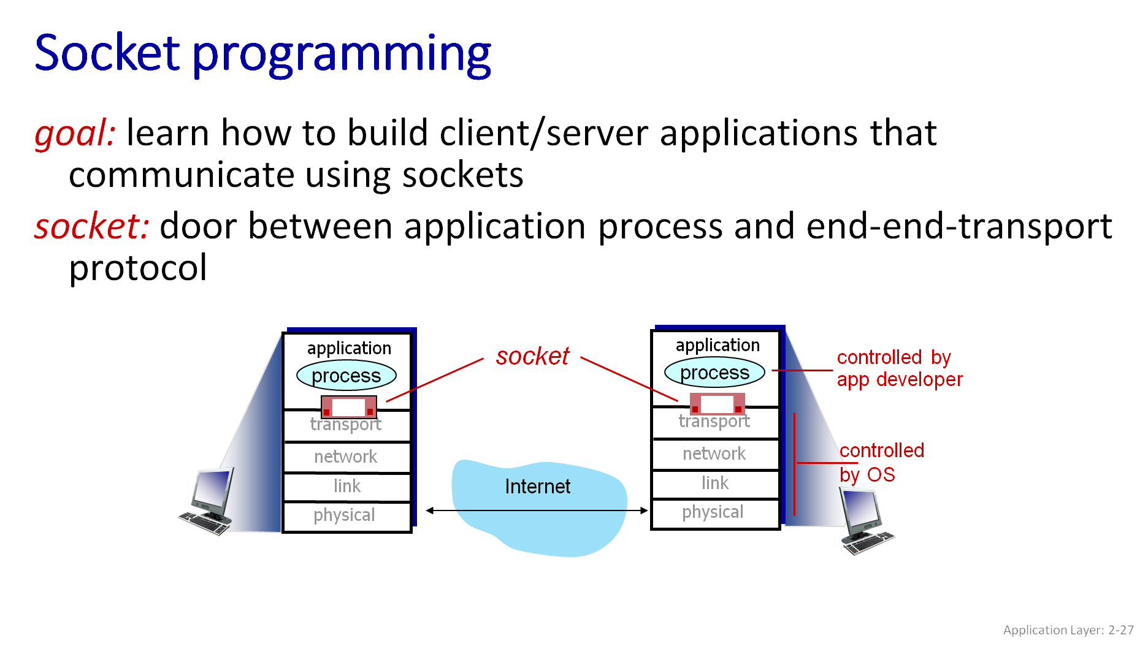

Two socket types for two transport services:

* *UDP:* unreliable datagram
* *TCP:* reliable, byte stream-oriented

UDP: no “connection” between client and server:

* no handshaking before sending data
* sender explicitly attaches IP destination address and port # to each packet
* receiver extracts sender IP address and port# from received packet

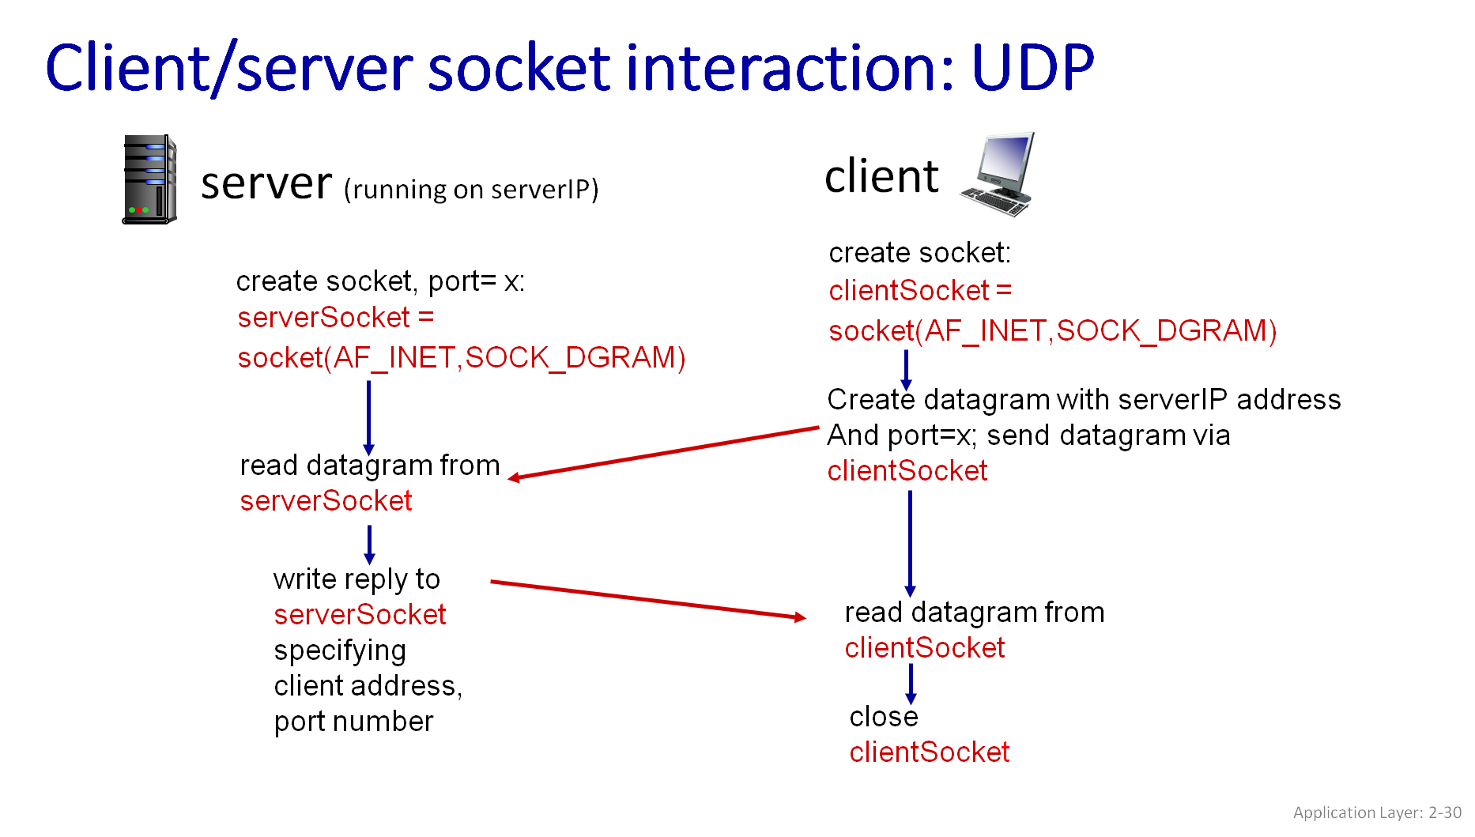

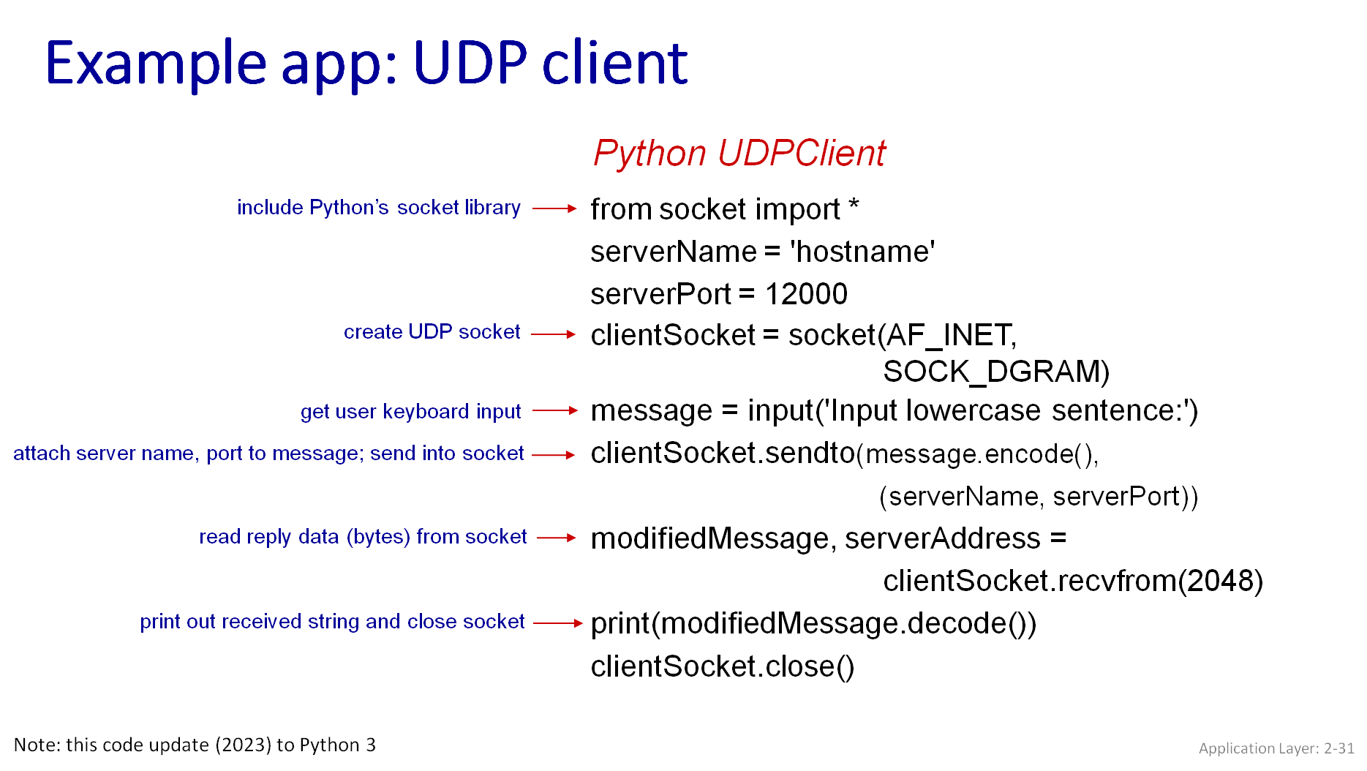

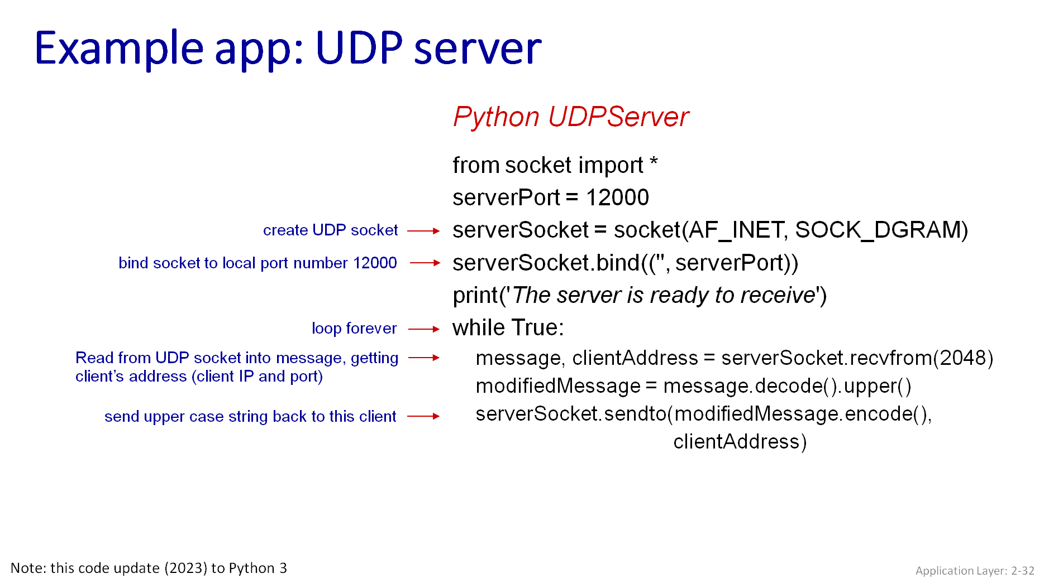

**Syntax to use ns3:**

All code files must be in specific folder to be executed, write following commands:

* Cd ns3-allinone-
* Cd ns-3.x
* Cd scratch
* Touch file.py

**Run command:**

* ./ns3 run file.py

**Libraries:**

* import ns.applications
* import ns.core
* import ns.internet
* import ns.network
* import ns.point_to_point
* From socket import *

**Output:**